**Papers prerequisities**

* an introduction to DeepFake
  + <https://www.alanzucconi.com/2018/03/14/introduction-to-deepfakes>
  + <https://medium.com/twentybn/deepfake-the-good-the-bad-and-the-ugly-8b261ecf0f52>
* detailed description of DeepFakes
  + <https://arxiv.org/pdf/1805.11729.pdf>
* Adversarial Attacks
  + <https://towardsdatascience.com/evasion-attacks-on-machine-learning-or-adversarial-examples-12f2283e06a1>

**Programming Prerequisities**

* *Python* programming experience 2+ years
* *Git* experience 0.5 year, but not so confident
  + *GitHub* confident usage
* *Jupyter Notebook* experience 0.5 year
  + played with Colab
* Learnt *OpenCV*
  + [https://pythonprogramming.net/loading-images-python-opencv-tutorial](https://pythonprogramming.net/loading-images-python-opencv-tutorial/)
* *Python venv* 1.5 year experience
* Played with *PyTorch*

**Practice & Read Something Else**

* ssh, sftp server, client on Linux, Windows
  + <https://medium.com/@olyushkam/remote-server-access-using-ssh-protocol-c5780821950c?sk=4328003f4aa4dde7f2c2efc0d0c69075>
* playing with deepdream­­ in­­ colab :) these are my mockingbird images)

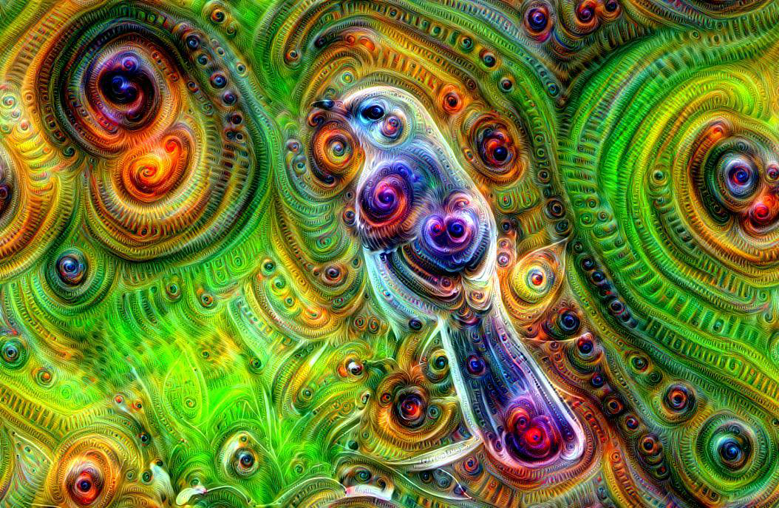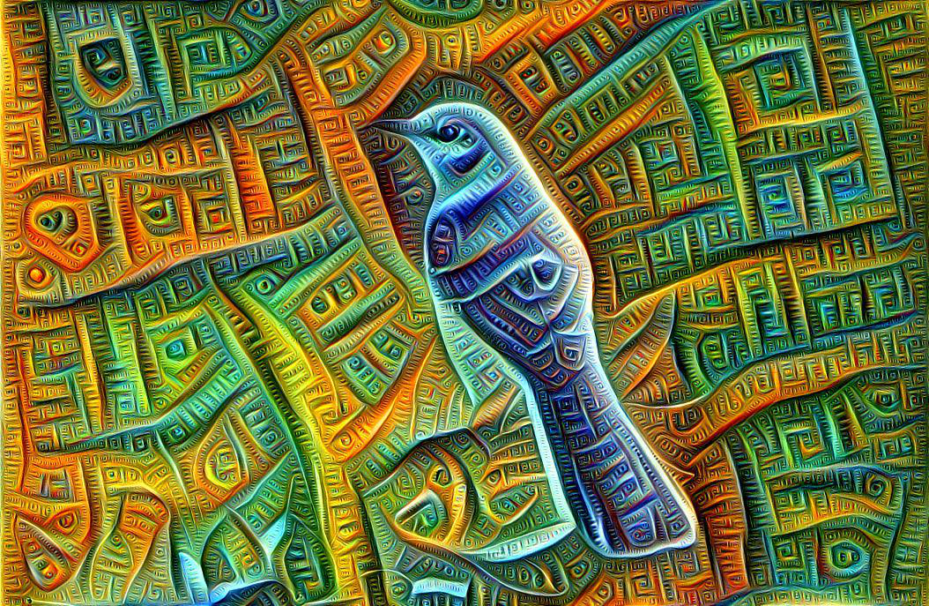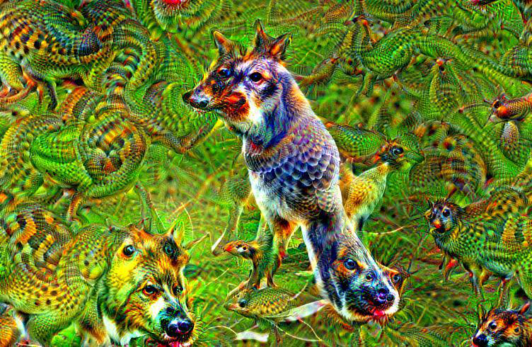

* CycleGAN paper
  + <https://arxiv.org/pdf/1703.10593.pdf>
  + <https://github.com/junyanz/CycleGAN>
  + shoutout of failure cases:

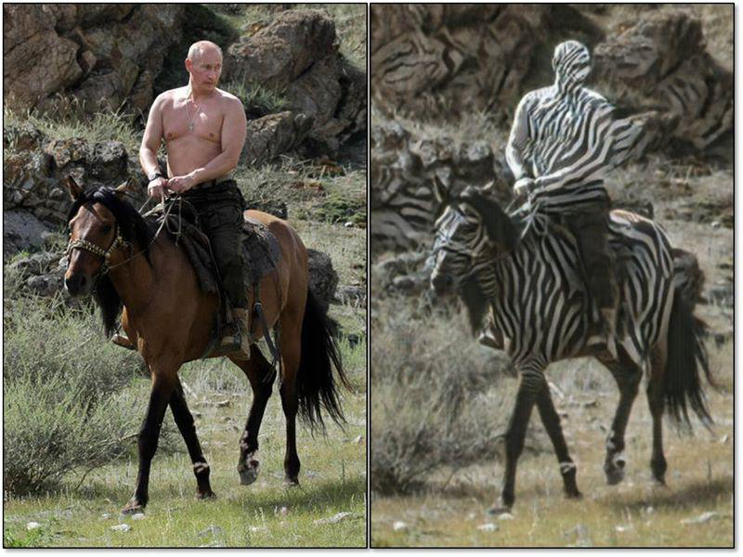

* Deepfake for dance moves paper
  + <https://arxiv.org/pdf/1808.07371.pdf>
* Deepfake video from few shots paper
  + <https://arxiv.org/pdf/1905.08233.pdf>

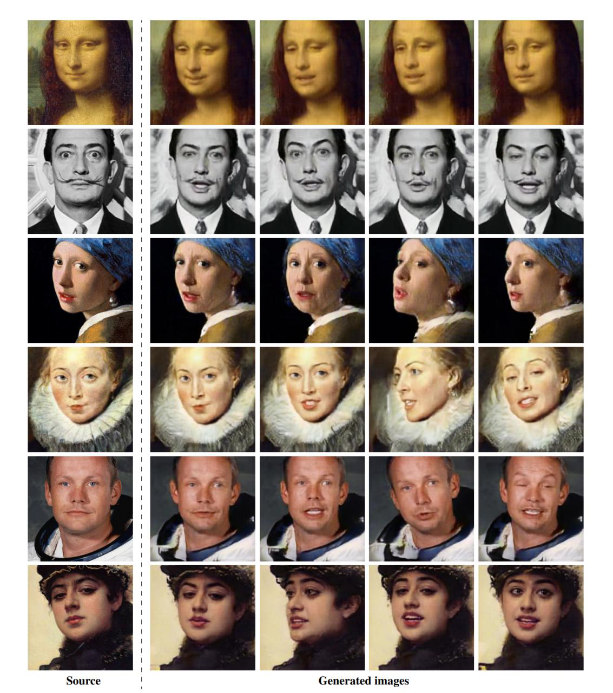

* Deepfake visual detection article
  + <https://medium.com/@kcimc/how-to-recognize-fake-ai-generated-images-4d1f6f9a2842>
  + a bit of a practice on [www.thispersondoesnotexists.com](http://www.thispersondoesnotexists.com)
* PyTorch Autograd Mechanism
  + <https://towardsdatascience.com/pytorch-autograd-understanding-the-heart-of-pytorchs-magic-2686cd94ec95>
  + <https://www.cs.toronto.edu/~rgrosse/courses/csc321_2018/slides/lec10.pdf>
  + <https://github.com/HIPS/autograd>
  + <https://github.com/mattjj/autodidact>
* Check Pillow while practicing PyTorch
  + [www.pillow.readthedocs.io/en/stable/](http://www.pillow.readthedocs.io/en/stable/)
  + accidentally find it in libs on Ubuntu, shoutout and make a meme

